Declaring Independence
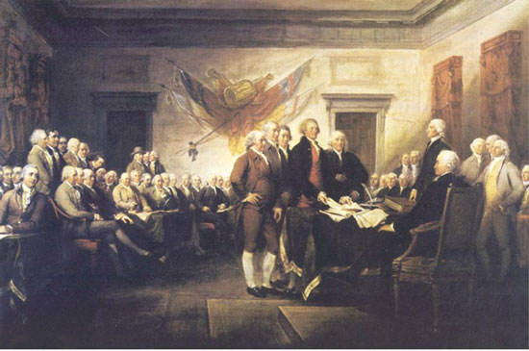
More than a year past between the outbreak of fighting at the battles of Lexington and Concord and the decision to issue the Declaration of Independence. The major reason for the delay was the high value that the colonists attached to unanimity. While New England, Virginia, and South Carolina were ready to declare independence in 1775, other colonies still hoped that British merchants or the parliamentary opposition would respond to American grievance. Many feared that a full-scale war for independence might give France and Spain the opportunity to expand their New World empires.
After the outbreak of violence, pressure began to build for a formal declaration of independence. During the Spring of 1776, colonies, localities, and groups of ordinary Americans--including New York mechanics, Pennsylvania militiamen, and South Carolina grand juries--adopted resolutions endorsing independence.
On June 7, 1776, a Virginia delegate forced the delegates to take a stand. Richard Henry Lee offered a resolution calling for an immediate declaration of independence. His resolution read:
That these United Colonies are, and of right out to be, free and independent States, that they are absolved from all allegiance to the British crown, and that all political connection between them and the state of Great Britain is, and ought to be, totally dissolved.
That it is expedient forthwith to take the most effectual measures for forming foreign alliances.
That a plan of confederation be prepared and transmitted to the representative colonies for their consideration and approbation.
Four days later-three weeks before Congress actually voted on Lee's resolution-the Continental Congress appointed a committee consisting of Thomas Jefferson, John Adams, Benjamin Franklin, Roger Sherman, and Robert R. Livingston to draft a declaration of independence.
According to John Adams, Jefferson suggested that Adams write the first draft. Adams later recalled the conversation:
I said, "I will not," "You should do it." "Oh! no." "Why will you not? You ought to do it." "I will not." "Why?" "Reasons enough." "What can be your reasons?" "Reason first, you are a Virginian, and a Virginian ought to appear at the head of this business. Reason second, I am obnoxious, suspected, and unpopular. You are very much otherwise. Reason third, you can write ten times better than I can." "Well," said Jefferson, "if you are decided, I will do as well as I can." "Very well. When you have drawn it up, we will have a meeting."
The committee delegated Thomas Jefferson to undertake the task. Jefferson, who was just 33 years old, was the Continental Congress's youngest member.
The draft was reviewed first by Adams, followed by Benjamin Franklin, and then by the entire committee. The committee made forty-seven alterations in Jefferson's draft and inserted three new paragraphs. The revised draft was presented to Congress on June 28.
In a famous clause that was ultimately deleted from the Declaration of Independence, Thomas Jefferson (1743-1826) cited the African slave trade as one of the examples of British oppression. Jefferson refers to the English government's repeated vetoes of attempts by colonial legislatures to restrict or halt the importation of slaves. Virginia, especially, had profited from a great natural increase in its slave population and had no desire for a further slave "surplus" or for competition with its own profitable practice of selling slaves to South Carolina and Georgia.
After voting for independence on July 2, the Congress then continued to refine the document, making thirty-nine additional revisions to the committee draft and trimming the document by a third before finally adopting the declaration on the morning of July 4.
The most radical idea advanced by the American Revolutionaries was the proposition set forth in the Declaration of Independence that "all men are created equal, that they are endowed by their Creator with certain Unalienable Rights, that among these are Life, Liberty, and the pursuit of Happiness." In 1856, Senator Rufus Choate (1799-1859) would dismiss this phrase as "glittering...generalities" (prompting the philosopher Ralph Waldo Emerson (1803-1882) to quip: "Glittering generalities? They are blazing ubiquities!").
One of the most important themes in American history involves the repeated effort to extend the meaning of the "inalienable rights" with which Americans are endowed and adopt a more inclusive definition of those who are "created equal." In the decades preceding the Civil War, reformers pictured their efforts to improve the nation's educational system and to abolish slavery as attempts to realize the republican ideals enshrined in the Declaration of Independence.
Proponents of abolition, women's rights, world peace, and other reforms drafted "Declarations of Sentiments" modeled on the wording of the Declaration of Independence. Workingmen's parties in New York and Philadelphia in the 1820s, abolitionists in the 1830s, and advocates of women's rights in 1848 each issued declarations listing a "history of repeated injuries and usurpations" that justified their proposed reforms. Convinced that the sacred principles of the revolution had been corrupted, reformers sought to revive the Spirit of 1776 by exposing a host of abuses that contradicted the nation's revolutionary principles.
Exploration 1: Declaring Independence
- What was the Declaration of Independence's primary purpose?

- Who was its intended audience?

- On what grounds does the document justify the colonists' demand for political independence? Do you find these reasons persuasive?

- Some eighty-six alterations were made between Jefferson's original draft and the version ultimately adopted by the Second Continental Congress. What are the most significant changes? Why do you think Congress made those changes? Did the alterations strengthen or weaken the document?

- One of the most significant changes involved delete Jefferson's discussion of slavery. What did Jefferson have to say about slavery in the original draft? Why do you think Congress removed this section of the Declaration?

- Why doesn't the Declaration refer to the British Parliament and why does it place so much emphasis on the actions of the king?

- What did Jefferson mean when he wrote that "all men are created equal, that they are endowed by their Creator with certain unalienable Rights"?

