Costume Design Worksheet Name: ______________________________________hour: _____

Play Title: ______________________________Character’s name & age: _______________________________
Scene Description: __________________________________________________________________________________________
Time Period: _______________Time of Day: ____________________ Season: __________________________
Character’s Family description:________________________________________________________________
Character’s Personality: __________________________________________________________________________________________
Description of other characters in scene: __________________________________________________________________________________________
Explain: How does the costume express the following -
The Mood and Spirit of the Character? (how do the clothes/accessories you chose show the character’s mood?) How?_______________________________________________________________________________________________________________________________________________________________________________________________
The Historical Period of the Play? (how do the clothes/accessories tell us what time period he/she is living in?) _______________________________________________________________________________________________________________________________________________________________________________________________
The Locale (place) of the Play? (how do the clothes/accessories tell us where he/she is?) _______________________________________________________________________________________________________________________________________________________________________________________________
The Socioeconomic status and personality of the character? (how do the clothes/accessories tell us their wealth/class) _______________________________________________________________________________________________________________________________________________________________________________________________
The Season of the year? How? (How can we tell what season it is due to what he/she is wearing?) ____________________________________________________________________________________________________________________________________________________________________________________________________
You will turn in one design. Use the notes and images below as a guide for your design.
Your final design should have:
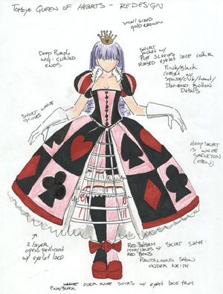
- the title of the play
- the character’s name
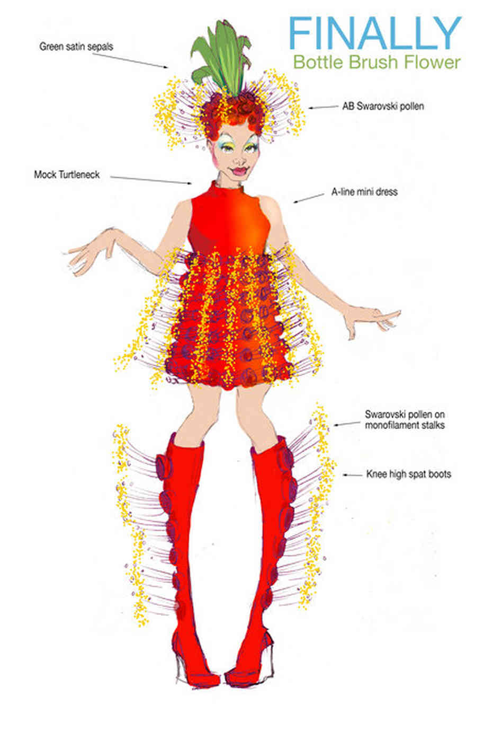
- the act and scene
- your signature
- colored in clothing
- list of garments and notes for details (following page)

List and describe all items:
Top style and color: __________________________________________________________________________________________
Bottom style and color: __________________________________________________________________________________________
Hair style and color: __________________________________________________________________________________________
Shoes style and color: __________________________________________________________________________________________
Tights or socks: __________________________________________________________________________________________
Hat:
__________________________________________________________________________________________
Watch or jewelry: __________________________________________________________________________________________
Extra Accessories:
__________________________________________________________________________________________
Write out how each of the above items relate to your character and why you made the choices you made.
__________________________________________________________________________________________________________________________________________________________________________________________________________________________________________________________________________________________________________________________________________________________________________________________________________________________________________________________________________________________________________________________________________________________________________________________________________________________________________________________________________________________________________________________________________________________________________________________________________________________________________________________________________________________________________________________________________________________________________________________________________________________________________________________________________________________________________________________________________________________________________________________________________________________________________________________________________________________________________________________________________________________________________________________________________________________________________________________________________________________________________________________________________________________________________________________________________________________________________________________________________________________________________________________________________________________________________________________________________________________________________________________________________________________________________________________________________________________________________________________________________________________________________________________________________________________________________________________________________________________________________________________________________________________________________________________________________________________________________________________________________________________________________________________________________________________________________________________________________________________________________________________________________________________________________________________________________________________________________________________________________________________________________________________________________________________________________________________________________________________________________________________________________________________________________________________________________________________
Set Design Worksheet Name: _____________________________________________________ Hr: _____
Scene Name and description: ____________________________________________________________________________________________________________________________________________________________________________________________________
Characters in the Scene: ______________________________________________________________________________
Time of Day: ____________________ Season: ______________________
How will the Actors interact with the set? ____________________________________________________________________________________________________________________________________________________________________________________________________
Explain: How does the set express the following -
The Mood and Spirit of the Play? (What things are included in your design that show the mood/spirit) ____________________________________________________________________________________________________________________________________________________________________________________________________
The Historical Period of the Play? (how do the set & set pieces help us understand the time period?) ____________________________________________________________________________________________________________________________________________________________________________________________________
The Locale (place) of the Play: (how do the set & set pieces help us understand where this is taking place?) ____________________________________________________________________________________________________________________________________________________________________________________________________
The Socioeconomic status and personality of the characters? (what things are included to show the wealth/class?) ____________________________________________________________________________________________________________________________________________________________________________________________________
The Season of the year? (what details are included to show what season it is?) ____________________________________________________________________________________________________________________________________________________________________________________________________
You will turn in one design. It should be a colored design from the view of the audience.
Your final design should have:
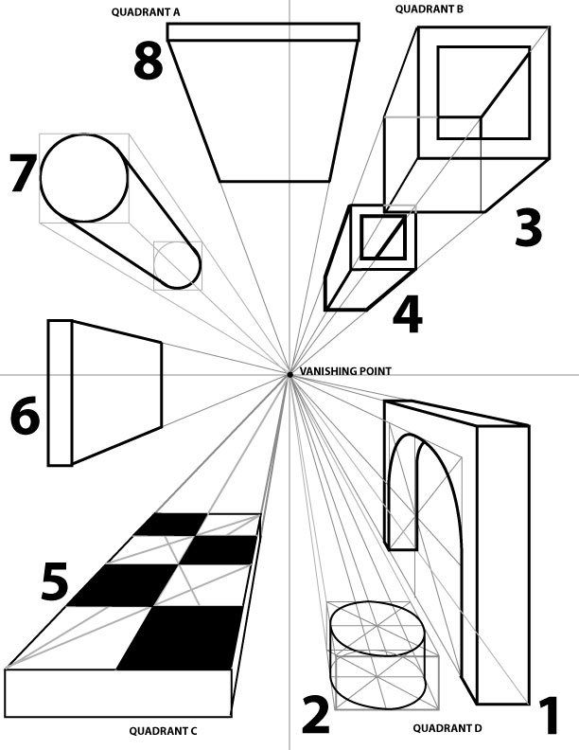
- the title of the play
- the scene
- your signature
- color on furniture, walls and floor
- perspective

Intro to Theatre Costume Design Rubric:
Name: __________________________________________________________ Hr. __________
 | 1 | 2 | 3 | 4
Period | Design is not in the correct period | Design has elements of the correct period | Design is mostly in the correct period | Design is in correct period and includes specific details of the era.
Personality | Design does not reflect personality and cannot be explained | Design reflects some or little of personality and some are defendable | Design reflects personality with a few discrepancies, most is explained. | Design is “perfect” for personality of character and all aspects can be defended and explained
Script Description/Information | Design does not follow script.  Costume Design worksheet not turned in. | Design follows some of the script. Worksheet was partially completed. | Design follows most of the script. Worksheet was handed in and completed. | Design follows script and also includes details that go in depth for the character. Worksheet was completed with great detail.
Overall effect and ability to describe costume. | Costume does not have any effect and no description | Costume has a little effect and little description | Costume has an effect, but it may not be accurate or does not have full description | Costume has impact and a full description of its effect.

Intro to Theatre Set Design Rubric:
Name: __________________________________________________________ Hr. __________
 | 1 | 2 | 3 | 4
Period | Design is not in the correct period | Design has elements of the correct period | Design is mostly in the correct period | Design is in correct period and includes specific details of the era.
Personality/ Mood | Design does not reflect personality and cannot be explained | Design reflects some or little of personality and some are defendable | Design reflects personality with a few discrepancies, most is explained. | Design is “perfect” for personality and mood of the play and explained well.
Script Description/  Information | Design does not follow script. Random furniture. Set Design Worksheet not turned in. | Design follows some of the script, but does not have all the required furniture. Worksheet was partially completed. | Design follows most of the script, and has most of what is needed. Worksheet was handed in and completed. | Design follows script and also includes details that go in depth for the scene. Worksheet was completed with great detail.
Overall effect and ability to describe set. | Set does not have any effect and no description | Set has a little effect and little description | Set has an effect, but it may not be accurate or does not have full description | Set has impact and a full description of its effect.

Total combined set and costume design score: ___/32

