Essential Background on *Beowulf*

SWBAT understand the historical context of *Beowulf* and its significance as a work of literature.

Show Holt Video Clip

What do we learn about Grendel?

__________________________________________________________________________________________________________________________________________________________________________

What do we learn about Beowulf?

__________________________________________________________________________________________________________________________________________________________________________

<http://www.readwritethink.org/files/resources/interactives/beowulf/>

Overview

1. *Beowulf* was written around _________________________________.
2. It was written in _______________________ and is considered______________________________.
3. It was written during the _____________________________ period.

Plot of the Story

1. *Beowulf* takes place ______________________________________________.
2. The first section tells _________________________________________________________________________________________________________________________________________________________________________.
3. The second section tells _________________________________________________________________________________________________________________________________________________________________________.
4. The third section tells _________________________________________________________________________________________________________________________________________________________________________.

Significance

1. *Beowulf* is significant because__________________________________________________________________________________________________________________________________________________________________.

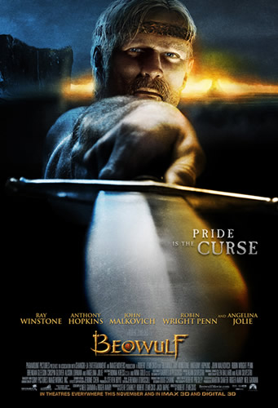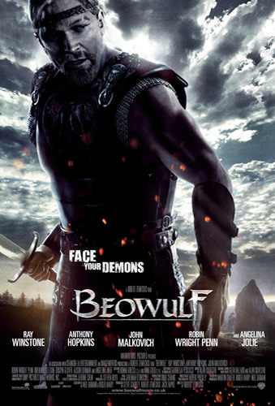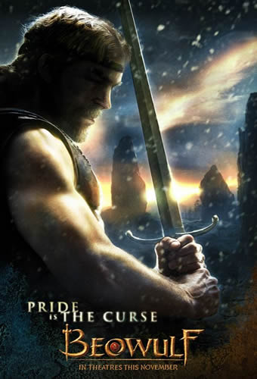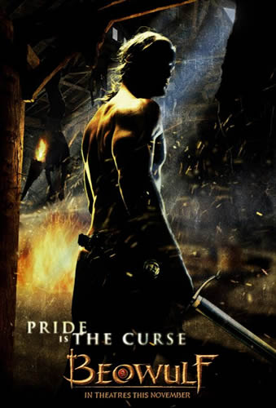

Look closely at the four posters for the movie *Beowulf*.

1. What do you notice first - what is your eye drawn to in each poster, and why?

________________________________________________________________________________________________________________________________________________________________________________________________________________________________________________________________________________________________

1. From looking at the posters, what do you think this film might be about - what characters, themes, and settings might you expect to see? ________________________________________________________________________________________________________________________________________________________________________________________________________________________________________________________________________________________________
2. What do you think the mood of the film might be?

________________________________________________________________________________________________________________________________________________________________________________________________________________________________________________________________________________________________

1. Try to find as many adjectives as possible to describe the ideas you have, based on what you can tell from the poster campaign.

________________________________________________________________________________________________________________________________________________________________________________________________________________________________________________________________________________________________